Mutual Fund Analytics Platform
Blue stock Fintech Capstone Project
Author: Yash Gothi
Tools Used: Python, Pandas, NumPy, SQLite, SQL Alchemy, Jupyter Notebook, Power BI, Git, GitHub
Project Duration: Day 1 – Day 4
Report Version: Final Submission

Executive Summary
The Mutual Fund Analytics Platform was developed to analyze mutual fund performance, investor behaviour, portfolio risk, and industry trends using historical and transactional data. The project integrates data engineering, data analytics, risk analytics, SQL database design, and dashboard visualization into a single end-to-end analytics solution.
The platform processes ten mutual fund datasets containing fund metadata, NAV history, investor transactions, AUM information, portfolio holdings, and benchmark data. Through ETL pipelines, data quality validation, database modelling, and analytical reporting, the project provides actionable insights for investors, fund managers, and financial institutions.
Key outcomes include investor segmentation, risk-adjusted fund performance evaluation, Value-at-Risk analysis, SIP continuity monitoring, portfolio concentration assessment, and a rule-based fund recommendation engine.

1. Project Objectives
Business Objectives
The project aims to:
- Analyze mutual fund performance across multiple schemes.
- Evaluate investor behaviour and transaction patterns.
- Measure portfolio risk using quantitative risk metrics.
- Monitor SIP continuity and investor retention.
- Compare fund diversification and concentration levels.
- Develop dashboards for executive decision-making.
- Create a recommendation framework based on investor risk profiles.
Technical Objectives
- Build ETL pipelines using Python.
- Design a star-schema SQLite data warehouse.
- Implement SQL analytics and reporting.
- Create Power BI dashboards.
- Perform risk analytics using historical returns.
- Document the complete analytics workflow.

2. Data Sources
The project utilizes ten datasets:
Dataset | Description
Fund Master | Scheme metadata
NAV History | Historical daily NAV values
AUM by Fund House | Assets under management
SIP Inflows | Monthly SIP trends
Category Inflows | Category-level investment flows
Industry Folio Count | Industry growth metrics
Scheme Performance | Return and risk measures
Investor Transactions | Investor transaction history
Portfolio Holdings | Security and sector holdings
Benchmark Indices | Market benchmark data
External API
mfapi.in
Used for live NAV retrieval and validation of scheme performance.

3. ETL Design & Data Engineering
Project Architecture
Raw Data → Data Cleaning → Validation → SQLite Warehouse → Analytics → Power BI Dashboard
Data Cleaning Activities
- Missing value handling
- Duplicate removal
- Data type standardization
- Transaction type normalization
- Date parsing and validation
- NAV validation
- Expense ratio validation
- KYC status verification
Data Quality Controls
- Referential integrity checks
- Row count validation
- Duplicate detection
- Range validation rules
- Null value analysis

4. Database Design
Star Schema Overview
Dimension Tables
dim_fund
Contains fund metadata.
dim_date
Calendar dimension supporting time-series analysis.
Fact Tables
fact_nav
Daily NAV records.
fact_transactions
Investor transactions.
fact_performance
Risk and return metrics.
fact_aum
Fund house AUM records.
Database Benefits
- Faster analytical queries
- Reduced redundancy
- Better dashboard performance
- Improved scalability
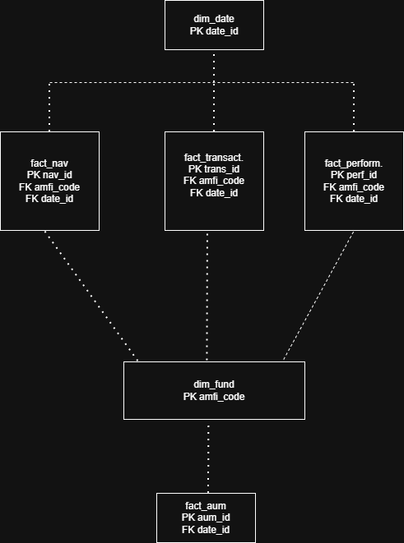

5. Exploratory Data Analysis
Investor Demographics
Age Group Distribution
Key findings:
- Majority of investors belong to the working-age population.
- Younger investors show increasing participation.
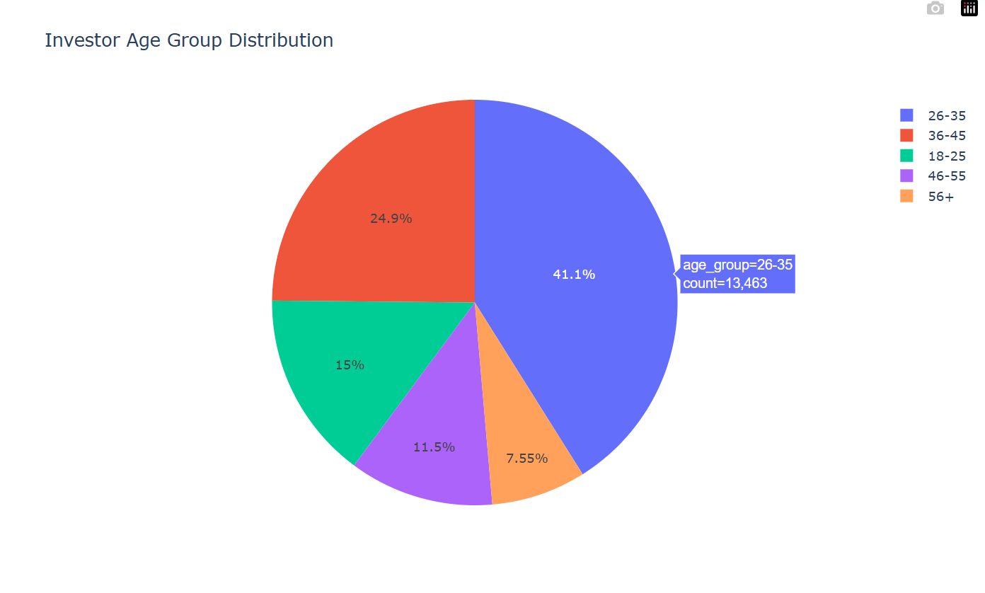

Gender Distribution
Key findings:
- Male investors represent the majority share.
- Female participation continues to grow.

Geographic Analysis
SIP Amount by State
Key findings:
- Major metro states contribute most investments.
- Significant opportunity exists in underpenetrated regions.
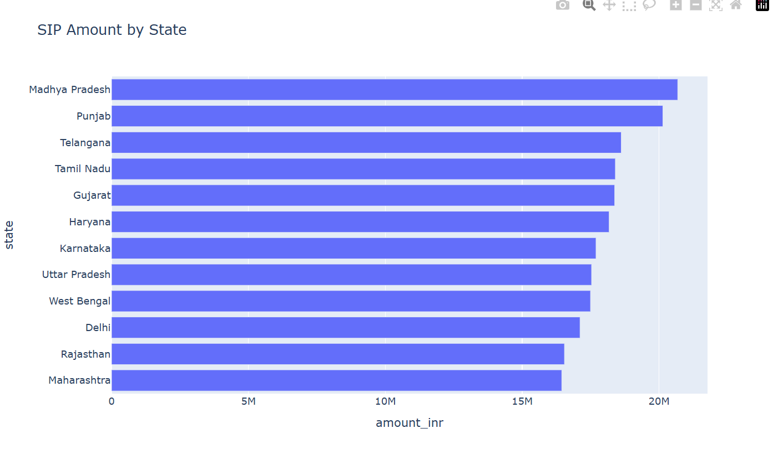

T30 vs B30 Analysis
Key findings:
- T30 cities dominate investment activity.
- B30 growth indicates improving financial inclusion.
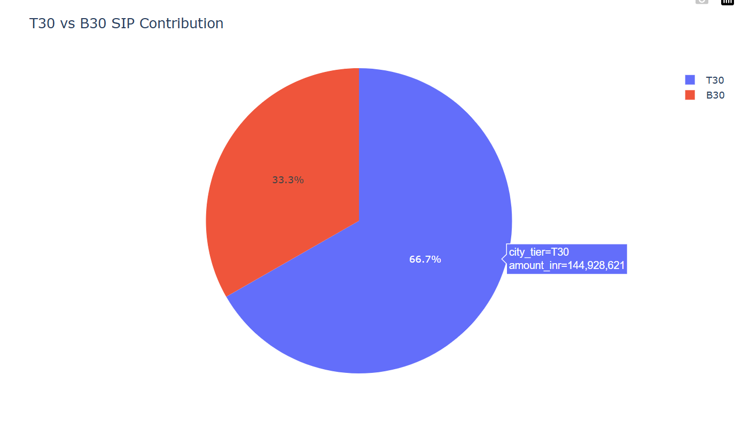

6. Mutual Fund Performance Analysis
Return Analysis
Metrics evaluated:
- 1-Year Returns
- 3-Year Returns
- 5-Year Returns
Key findings:
- Large-cap funds demonstrated consistent performance.
- Some funds significantly outperformed benchmarks.
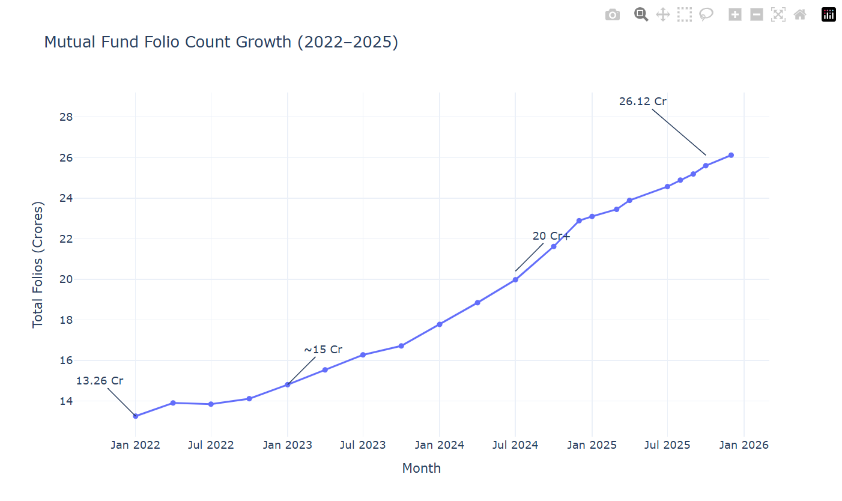

Risk-Adjusted Performance
Metrics:
- Sharpe Ratio
- Sortino Ratio
- Alpha
- Beta
Key findings:
- High Sharpe Ratio funds delivered superior risk-adjusted returns.
- Several funds generated positive alpha against benchmarks.
(Insert Risk Analysis Dashboard)

7. Risk Analytics
Historical Value-at-Risk (VaR)
Methodology:
- Daily return calculation
- 5th percentile estimation
Findings:
- Certain schemes exhibit significantly higher downside risk.
- Risk varies considerably across categories.

Conditional Value-at-Risk (CVaR)
Methodology:
- Average loss below VaR threshold
Findings:
- CVaR identified tail-risk exposure not visible through standard volatility measures.

Rolling 90-Day Sharpe Ratio
Findings:
- Performance stability differs across funds.
- Some funds maintain consistently superior risk-adjusted returns.
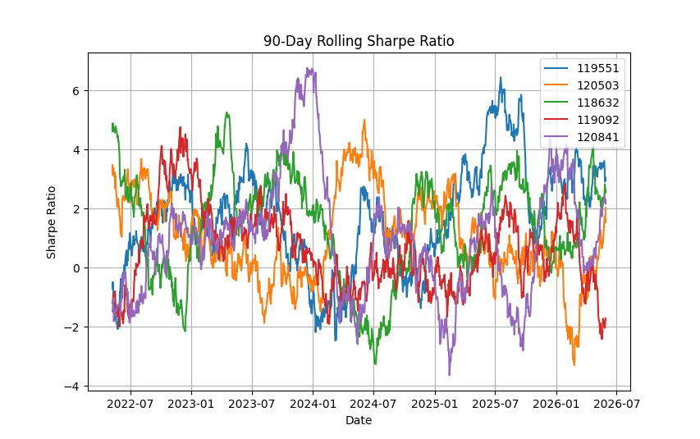

8. Investor Behaviour Analytics
Cohort Analysis
Findings:
- Newer investor cohorts invest larger amounts.
- Average SIP values have increased over time.
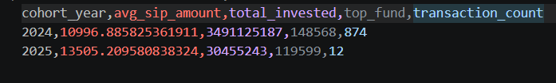)

SIP Continuity Analysis
Findings:
- Most investors maintain regular SIP schedules.
- At-risk investors identified through transaction gap analysis.
(Insert SIP Continuity Dashboard)

9. Portfolio Diversification Analysis
HHI Concentration Analysis
The Herfindahl-Hirschman Index (HHI) was used to evaluate portfolio concentration.
Findings:
- Some equity funds exhibit concentrated sector exposure.
- Diversified funds generally display lower concentration risk.
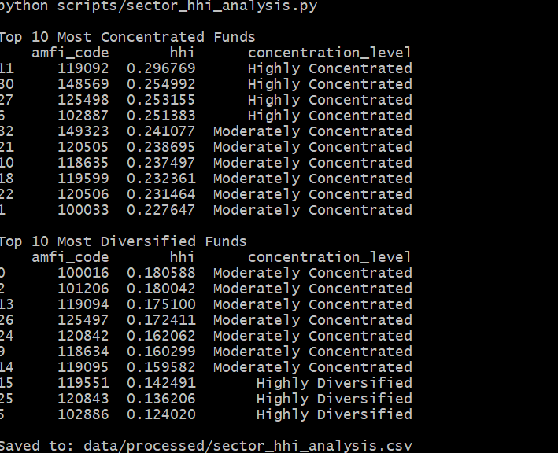

10. Fund Recommendation Engine
A rule-based recommendation system was developed using:
- Risk Grade
- Sharpe Ratio
- Fund Performance Metrics
Risk Categories
- Low Risk
- Moderate Risk
- High Risk
The engine recommends the top-performing funds within each risk profile.
(Insert Recommendation Output Screenshot)

11. Dashboard Overview
Dashboard Components
- Executive Summary
- Investor Analytics
- Fund Performance
- Risk Analytics
- Portfolio Concentration
- Geographic Analysis
(Insert Dashboard Screenshots)
Screenshot 1: Overview Dashboard

Screenshot 2: Investor Analytics Dashboard

Screenshot 3: Risk Analytics Dashboard
Screenshot 4: Fund Performance Dashboard

12. Key Insights
Insight 1
Funds with the highest VaR values exhibited significantly larger downside exposure.
Insight 2
Recent investor cohorts contribute the largest investment volumes.
Insight 3
A small group of states account for the majority of SIP investments.
Insight 4
Higher Sharpe Ratio funds consistently outperform peers on a risk-adjusted basis.
Insight 5
Portfolio concentration varies significantly across equity schemes.

13. Limitations
- Historical performance does not guarantee future returns.
- Limited availability of live market data.
- Simplified recommendation engine.
- Assumed transaction consistency for SIP analysis.
- Portfolio holdings snapshots may not represent real-time allocations.

14. Recommendations
For Investors
- Focus on risk-adjusted returns rather than absolute returns.
- Maintain SIP discipline for long-term wealth creation.
- Diversify across categories and sectors.
For Fund Houses
- Improve investor engagement in B30 regions.
- Monitor SIP continuity to reduce churn.
- Promote diversified investment strategies.
For Future Enhancements
- Machine Learning-based recommendation engine.
- Real-time NAV integration.
- Portfolio optimization models.
- Predictive investor churn analytics.
- Automated dashboard refresh pipelines.

Conclusion
The Mutual Fund Analytics Platform successfully combines data engineering, risk analytics, business intelligence, and investment analysis into a unified solution. The project demonstrates practical application of Python, SQL, Power BI, and financial analytics concepts while delivering meaningful insights into mutual fund performance and investor behaviour.

